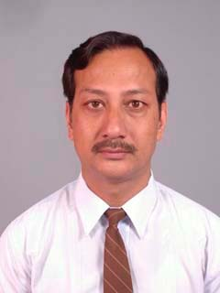
Curriculum – Vitae
Name in Full : Gyanendra Ratna Tuladhar, (Ph.D. Tourism Economical Science)
Date of Birth : 28th of April 1958

Citizenship : Nepali
Contact Address : Paleswan Marga 178, Nayabazaar, Khusibun Town Planning
Tel: 4388938, Mob. 9841-533967, e-mail: grtuladhar@gmail.com
Academic Background : Ph.D. - Tourism Economical Science - 1993
Sofia University, The Higher Testimonial Committee, Sofia BULGARIA. Equivalent honored by Tribhuvan University, Kirtipur
Thesis Title "Econometric Modulation of International Tourism Development in the Kingdom Nepal for Sustainable Development - Resources Management, Socio-econometric modulation and Market Promotion".
B.Sc. & M. Sc. (M.A.) - Tourism Economy – 1987,
Economic University, VINS – Varna, BULGARIA.
Equivalent honored by Tribhuvan University, Kirtipur,
Thesis Title “Development of International Tourism in the Kingdom Nepal –
Resource Management and Market Promotion"
B. Com. - Commerce and Public Administration,
Tribhuvan University, Public Youth Campus, Kathmandu, 1980
My personal Qualification, affiliations, experiences and publications are detailed in Annexes 1-10:
Annex 1. Strategic Recommendations: “Reimagining Tourism for a New Nepal” 1
Annex 2. My Thesis Findings and Philosophy: 3
Annex 3. Qualifications and Key Subject of the studies: 4
Annex 4. Professional Affiliations since 1993 4
Annex 5. a) Personal Trainings, b) Language Efficiency c) Award received d) Country visited and e) Places visited 5
Annex 6. Paper Presented and Workshop Organized 6
Annex 7. Working Experience in Academic field (affiliated in TU, PU and KU): 8
Annex 8. Working Experience in Curriculum Developing for TU Academic: 9
Annex 9. Working Experience in Tourism Industry (Private Organization/Firms) 10
Annex 10. Working Experience in Government, Semi-Government, Local Government and Project Planning and Execution: 11
Annex 11. Publications of Research, Reports and Articles: 20
Annex 12. Strategic Recommendations: “Reimagining Tourism for a New Nepal” 22

References:
  - Dr. Roop Jyoti Kansakar, Chairman, Jyoti Group, mob: 9851007117
  - Manohar SJB Rana, CEO, Yeti Travels Pvt. Ltd. Contact 01-4221234, mob: 9801110331

Certification: I, the undersigned, certify that to the best of my knowledge and belief, this bio-data correctly describes my qualifications, experiences and myself. I understand that any willful misstatement described herein may lead to the ultimate disqualification or dismissal, if employed. Thank you.
_________________
SIGNATURE

My Thesis Findings and Philosophy:
Philosophical and Economic View
- Philosophy: Tourism is driven by what people feel and seek—it’s subjective. Visitors constantly search for unique natural and cultural experiences in increasingly exotic destinations.
- Physical Advantage: Nepal is physically ideal for developing vibrant international tourism. Given its dramatic, varied geography and global location, tourism is a powerful catalyst for development, helping the economy from the local to the national level.
- Poverty Reduction: Tourism is a flexible tool that can help reduce poverty by properly managing resources and creating sustainable activities.
Marketing and Opportunities
- Marketing Focus: Nepal is seen globally as a mystical, exciting, and exotic destination. It is a dreamland for mountain enthusiasts, a cultural showcase for seekers, and a spiritual home for the faithful.
- Tourism is a "Dream Industry": It sells a fantasy, and in this world of imagination, the potential is endless. The keys to long-term success are turning long-term visions into clear, actionable missions and effectively marketing them in this constantly changing industry.
- Opportunities: Tourism offers immense benefits, including:
  - Creating jobs and income.
  - Connecting remote areas.
  - Improving the living standard of communities.
  - Supporting related auxiliary industries.
  - Increasing foreign currency earnings.
  - Helping to conserve natural and cultural heritage.
  - Protecting the ecological biodiversity.
Challenges and Recommendations
- Sustainability Goal: Tourism is inherently linked to sustainable development. If managed well, it can lead the way in resource management, ensuring that economic, social, and aesthetic needs are met without harming cultural integrity, essential ecological processes, or biodiversity.
- Main Challenges (Focused): Nepal relies heavily on international tourism, but the industry is unstable (volatile and vulnerable) due to:
  - Centralism (too focused on certain areas).
  - Seasonality (too dependent on specific times of the year).
  - Inadequate infrastructure.
- Recommendations: To stabilize the industry and ensure long-term stability (perpetual sustainability), both the government and the private sector must work together with sensitivity and strong coordination.
  - The primary recommendation is implementing a genuine, complete, and integrated tourism plan that includes:
    - Progressive decentralization.
    - Effective resource conservation and mobilization.
    - Strong people's participation.
    - Clear political commitment backed by effective laws and decrees.
    - Targeted marketing.
  - The essential 'software' needed is raising awareness, education, and ecological consciousness to improve product quality.
  - The final goal is to improve tourism products and services to global standards to increase the country's "Touro-Dollar" income and establish international tourism as a highly effective sector of the Nepalese economy.

Qualifications and Key Subject of the studies:

- Sustainable Tourism Development and Management;
- Social Psychology, Organization and Technology in Tourism;
- Socio-culture and economic in Tourism;
- Consumer’s behavior n Motivation in Tourism
- Business Management in Tourism;
- Tourism Marketing and Promotion (NTO Marketing and Promotion);
- Geography of Tourism;
- History and Culture in Tourism;
- Balneology and Curative Tourism;
- Hotel and Catering Management;
- Economics and Organization in Tourism Management;
- Econometric Modulation of Statistics and Statistics in Tourism;
- Application of Mathematical Methods in Tourism Economics;
- Accounting in Tourism Management;
- Effectiveness, Efficiency and Pricing in Tourism Management;
- International Monetary and Financial Relation in Tourism;
- Automated Management System in Tourism;
- Micro Finance and Credit in Tourism;
- Political Economics in Tourism;
- Planning and Balance of National Economy;
- Computing Technology and Programming;
- Specialized Course in Seminar Management;
- Specialized Course in Tourist Guide.

Professional Affiliations since 1993
- 2017 – Treasurer and Executive Director, Nepal Ph.D. Association,
- 2015 – Executive Director, Udaaya Samaj, Kathmandu
- 2013 – Ex Board of Director, Kathmandu Upateka Khanepani Limited, KUKL
- 2011 – Ex Board of Director, Nepal Water Supply Corporation, NWSC
- 2010 – Faculty Member and Lecturer in Public Youth Campus
- 2006 – Advisor Village Tourism Promotion Forum Nepal (VITOF-N)
- 2005 – Lecturer in Nepal Academy of Tourism and Hotel Management, Ravi Bhavan
- 2005 – Life Member, Dharmodaya Sabha (National Buddhist Organization and WFB Nepal)
- 2003 – Life Member, Heritage Society of Bishalnagar-Hadigaon, KTM.
- 2002 – Lecturer in Culture Tourism: TU Padma Kanya Multiple Campus
- 2002 – E-Profession Member: Ecotourism Society, U.S.A.
- 2001 – Member: Sustainable Tourism Network, NTB, Kathmandu
- 1999 – Senior Consultant: National Travel & Tourism Consultants
- 1999 – Management Consultant: Thamel Tourism Development Committee
- 1998 – Member: Planning & Resource Mobilization, Siddhartha University – Nala
- 1997 – Member: Nepal-Israel Culture & Friendship Association, Kathmandu
- 1997 – Member: Nepal-Australia Culture & Friendship Association, Kathmandu
- 1996 – Member: MAN - Management Association of Nepal, Kathmandu
- 1996 – Faculty Member and Lecturer: REHDON College, Kathmandu
- 1996 – Faculty Member and Lecturer: TU Nepal Collage of Travel & Tourism Management
- 1996 – Executive Director: Nepal-German Hilfe Beilngries "Saligram Balgriha
- 1995 – Life Member: Nepal Heritage Society, Kathmandu
- 1994 – Member: Tourist Guide Association of Nepal, KTM
- 1994 – Ex-Executive Director: Kathmandu Environment Education Project,
- 1993 – Fellowship: Tourism Concern, U.K., 1992 – Fellowship: Association of Business Executive, U.K., 1991 – Fellowship: Association of Computer Machine, U.S.A., 1990 – Fellowship: American Computer Machine ACMBUL, Sofia, BULGARIA

a) Personal Trainings, b) Language Efficiency c) Award received
d) Country visited and e) Places visited
- Personal Trainings
- Trekking Tourism – Varna University, 1985
- City Tourist Guide, HMTTC, Kathmandu 1988
- Computer Software Application, ACMBUL, Varna Bulgaria, 1993, Word, Excel, Power Point, FreeHands, PhotoShops, Coral Draw, QuatroPro, LAN applications, Microsta – Statistic Analyses, SPSS (Statistic Program for Social Studies) and others.
- Tour Operations, Yeti Travels (Pvt.) Ltd. 1996
- Tour Operations and Tour Guide, Human Resources Development, SATS (South Asia Tourism Secretariat), South Asia Integrated Tourism Human Resource Development Program), Ktm, ‘97
- GIS Applications (ArcView, ArcInfo and ILWIS), Tribhuvan University, Kathmandu, 2002
- Languages & Degrees of Proficiency:
Language Reading Writing Speaking
1. Newari Mother Tongue Mother Tongue Mother Tongue
2. Nepali Native Native Native
4. English Excellent Excellent Excellent
5. Bulgarian Excellent Excellent Excellent
- Awards received:
- Ph.D. Tourism Economical Science – Merit Award, by The Higher Testimonial Committee - Economics University, Sofia, BULGARIA, 1993
- M.Sc. Tourism Economics– First Class Honored, by Economic University, Varna, BULGARIA, 1987.
- ‘Mahendra Vidya Vhushan’ - 1996, by His Majesty the King Birendra Bir Bikram Shah Dev
- ‘Scholarly Honored’, Gold Medal by “Shree Degukhyo Guthi”, 2000.
- Scholarly achievement honored by Village Tourism Promotion Forum and Nepal Tourism Board.
- Judge of ‘Nationwide Essay Competition’ by Nepal Tourism Board Award 2006
- Countries visited:
- India, United Kingdom, France, Germany, Austria, Belgium, Italy, Switzerland, Greece, Russia, Yugoslavia, Bulgaria, Romania, Czech, Slovakia, Poland, Hungary
- Places visited in Nepal:
- East to West and North to Southern part of Nepal: from Taplejung, Sankhuwasava, Ilam, Kakarbhita, Itahari, Inaruwa, Kositappu, Dharan, Biratnagar, Tumlingtar, Bhojpur, Nuwakot, Kaski, Pokhara, Annapurna Area, Chitwan, Lumbini, Kapilvastu, Palpa, Nepalgunj, Surkhet, Dolpa, Jumla, Humla

Paper Presented and Workshop Organized
- 2026 Jul, Feasibility Study of the Integrated Tourism Development Program in Bhaktapur PA Constituency No. 1 (Ka) - presented at Government of Bagamati Province, Ministry of Culture and Tourism, Hetauda, Makawanpur, Nepal, July 2026.
- 2025 Jul, Strategic Tourism Development Plan for Bagmati province (2025-2040), presented at Government of Bagamati Province, Ministry of Culture and Tourism, Hetauda, Makawanpur, Nepal, July 2025.
- 2019 Oct, “Scientific Tourism for Prosperous Nepal and Happy Nepal”, presented at International Youth Conference on Science, Technology and Innovation, 2019, (October 21-23), Kathmandu, Nepal, motto ‘Research and Innovation for Prosperity’, organized by NAST, in coordination with Ministry of Education, National Youth Council and Nepal Academic of Science and Technology, page 389-397.
- 2019 Aug, “Tourism for Prosperous Nepal and Happy Nepali”, presented at MoCTCA, organized by Nepal Ph.D. Association, Kathmandu
- 2008 June “Multi Stakeholders' Roundtable Conference and Workshop on Sustainable Tourism Development in Bhaktapur District”, Organized by Bhaktapur Tourism Development Council (BTDC), Bhaktapur
- 2008 June, “Multi Stakeholders' Roundtable Conference and Workshop on Sustainable Tourism Development in Bhaktapur District”, Organized by Bhaktapur Tourism Development Council (BTDC), Bhaktapur
- 2008 June, “Prospect of Village Tourism in Bhaktapur, Organized by BTDC, Bhaktapur
- 2008 June, Backward and Forward Market Linkage of Tourism, organized by BTDC, Bhaktapur
- 2008 June, Implementing Strategies for Sustainable Tourism Development in Bhaktapur District organized by BTDC, Bhaktapur
- 2008 June, Roles and Responsibilities of the Key Stakeholders in Sustainable Tourism Development Organized by BTDC, Bhaktapur
- 2007 Mar "Sammunnat Paryatana (Prosperious Sustainable Tourism) for Sambridda Nepal”, Organized by Loktantrik Paryatan Samaj, Thamel, Kathmandu
- 2007 Feb "Structural Appraisal for Prosperous Sustainable Tourism”, Organized by Loktantrik Paryatan Samaj, Thamel Tourism Development Council
- 2006 Sept "Lumbini – A Diamond Mine for Tourism Industry” Seminar on Pilgrimage Tourism in Lumbini, organized by Village Tourism Forum – Nepal.
- 2002 July "A structural linkage and dependency of Tourism Development in Nepal" for Public Private Partnership and NTB/NTO Appraisal, organized by Village Tourism Forum.
- 2002 Dec "Tourism package development - Focusing Rural Areas of Nepal" for Sustainable Rural Tourism Development, organized by Tourism for Rural Poverty Alleviation Program and NATHM.
- 2002 Nov-Dec: Series of Interaction with local people and tourism concern for "Public Hearing - Heritage Walks in the Kantipur City", organized by Kathmandu Metropolitan City.
- 2002 Jul "Role of Teacher and Students on Conservation Awareness of Cultural Heritage", organized by Kathmandu Metropolitan City (Culture, Heritage and Tourism Department, Department of Environment and Solid Waste Management)/KMC
- 2002 Jun "Tourism for Sustainable Development", presentation on Sustainable Tourism Network, “Nepal Tourism Board"
- 2002 May "Stakeholders Consultation Workshop, on Formulation of comprehensive and integrated long-term plan along with short-term action program for the Sustainable Development of Nepal's Tourism Sector " organized by MoCTCA, UNDP-WTO led Tourism for Sustainable Development Mission, NEP/02/005
- 2002 May "Tourism for Sustainable Development" Tourism Planning Workshop with the Stakeholders, the Tourism Industry Managers and the Tourism Academia, organized by MoCTCA, UNDP-WTO led Tourism for Sustainable Development Mission, NEP/02/005
- 2002 Mar "Heritage Walks, a concept of Culture Heritage Conservation and Promotion of Tourism", organized by Nepal Heritage Society
- 2001 Oct "Heritage Walks a Product Development Scheme of Tourism", Walk Through Heritage Sites and Explore the Unique Culture of Kathmandu, organized by Kathmandu Valley Mapping Program
- 2001 Mar "Ecotourism in Nepal – The Way Forward", A Discussion Workshop with Major Travel Industry and Stakeholders, organized by NTB and ADB led Ecotourism Project Team, TA 3332 NEP, Kathmandu
- 2000 Dec "Ecotourism in Nepal – Future Direction", A Discussion Workshop with Tourism Stakeholders, organized by NTB and ADB led Ecotourism Project Team, TA 3332 NEP, Kathmandu, December 2000
- 1997, Jun "Tourism Industry Standardization" series of the Stakeholder Consultation Workshop, organized by ADB led Tourism Sector Development Team, TA 2685-NEP, KTM.
- 1997, Nov "The Ninth Five Year Plan (1997-2002), A Major Tourism Stakeholder Consultation Workshop", organized by National Planning Commission, Kathmandu
- 1996, Dec "Nepal Tourism Board and Department of Tourism", as an alternative division, organized by UNDP led Partnership for Quality Tourism
- 1996, Oct "The Role of Private Sector in Promoting Tourism", Report on the Visit Nepal Year 1998, organized by VNY'98 and Image Nepal, Kathmandu.

Working Experience in Academic field (affiliated in TU, PU and KU):
Subject Matters Lecture on: | Since 1996 - University/Collage/Institution
- ‘Service Marketing’, TU-BBA, BBS, 8th Semester  - ‘Leadership and Organizational Behavior’, TU-BBM, 2nd Semester  - ‘Organizational Behavior and Management’, TU-BIM 2nd Semester.  - ‘Marketing for Manager’, PU-MBA, 1th Semester  - ‘Research Methodology’, KU-BBA, 6th Sem.  - ‘Research Project and Diploma Paper’, KU-BHM, 7th Semester.  - ‘Research Methodology and Statistics’, KU-BHM, 6th Semester.  - ‘Research Methodology’, PU, BBA, 5th Semester  - ‘Marketing Management’, PU, BBA, 3rd Semester  - ‘Principle of Marketing’, PU, BBA, 2nd Semester  - ‘Organizational Behavior’, PU, BBA, 5th Semester  - ‘Business Environment’, PU, BBA, 3rd Semester  - ‘Consumers Behavior’, PU, BBA, 7th Semester  - ‘Tourism Management’, PU, BBA, 6th Semester  - ‘Foundation of Travel and Tourism Mgmt, TU, BTTM, 1st Semester  - ‘Culture and Social Psychology for Tsm’, TU, BTTM, 4th Semester  - ‘Sustainable Tourism for Sustainable Development’, TU, BTTM, 5th Semester  - ‘Tourism Planning and Policy’, TU, BTTM, 6th Semester  - ‘Tourism in Nepal’, TU, BTTM, 2nd Semester  - ‘Tourism Marketing and Promotion’, TU, MBS, RD, 6th Semester  - ‘Rural Development, Ecotourism & Village Tourism’, MBS, RD  - ‘Entrepreneurship Development in Nepal’, TU, MBS, 1st Semester  - ‘Finance and Capital Structure Management’, TU, MBS, 3rd Semester  - ‘Culture Tourism’, for TU, BBS, 1st Semester  - Travel Trade Management and Tourist Service Operation and Management, 3rd Semester  - ‘Tourist Service Operations and Management on Tour, Trek & Rafting Management’, TU, BTTM | - Tribhuvan University, Public Youth Campus (PYC), Dhobichaur  - Tribhuvan University, Padma Kanya Campus, Bagbazaar  - Prime College, Khusibun, Kathmandu.  - Tribhuvan University, Trichandra Multiple Campus  - Nepal Academy of Tourism and Hospitality Management (NATHM),  - KU, LACM-BBA, Little Angels Collage of Management, Kathmandu  - SAAN International Collage, Faculty of Management, Kathmandu  - NATHM Nepal Academy of Tourism and Hotel Management, Rabi Bhavan, KTM  - Nepal College of Travel & Tourism Management, Kathmandu  - REHDON College, (College of Science and Management), Samakhusi, Kathmandu

Working Experience in Curriculum Developing for TU Academic:
Subject Matters
- Syllabus for Fundamental of Travel and Tourism Management (1st Sem Course outline), 2023, 2025
- Syllabus for Tourism in Nepal Syllabus (2nd Semester Course outline), 2023, 2025
- Culture & Social Psychology for Tourism (4th Semester Course outline), 2021, 2023
- Sustainable Tourism Development (5th Semester Course outline)
- Tour Guiding and Escorting (5th Semester Course outline)
- Tourism Entrepreneurship Development (5th Semester Course outline)
- Tourism Geography final TU (Final) (5th Semester Course outline)
- Adventure Tourism Syllabus (6th Semester Course outline)
- Event Management (6th Semester Course outline)
- Tourism in Nepalese Society and Politics 2 (6th Semester Course outline)
- Tourism Planning and Policies (6th Semester Course outline)
- Visitors Management (7th Semester Course outline)

Working Experience in Tourism Industry (Private Organization/Firms)
- Fishtail Air Pvt. Ltd., KTM  (Executive Manager – Admin) | Duties, Scope of Services and Activities includes:  Overall responsibility of Administration, Personnel, and Accounting of the company. | Feb 2010 – Feb 2011
- Everest Travel Service Pvt. Ltd  (Director Tours and Admin) | Planning, programming, packaging, marketing, sales and promotion; tour handling, trekking arrangement and operation on all travel trade needful for the company. | July 2000 – Aug 2001
- Mountain Dreams Pvt. Ltd.  Nepal-Germany Joint Venture.  (Business Manager, Director Tours and Admin) | Planning, programming, packaging, marketing, sales and promotion; tour handling, trekking arrangement and operation on all travel trade needful for the company. | Aug 1999 – Mar 2000
- Potala Travels, Nepal  (Director Tours and Admin) | Planning, programming, packaging, marketing, sales and promotion; tour handling, trekking arrangement and operation on all travel trade needful for the company. | Jan 1998 – Dec 1999
- Yeti Travels (Pvt.) Ltd.  (Joint Assistant Manager, Tour) | Planning, programming, packaging, marketing, sales and promotion; tour handling, trekking arrangement and operation on all travel trade needful for the company. Handled MICE Tourism, Incentive tours, Special interest packages; developed inclusive, exclusive, incentive and special interest tour packages. | Jan 1994 – Oct 1996
- United World Travel (Pvt.) Ltd.  (Tour Officer/Tourist Guide) | Tour Officer / City Tourist Guide – French and Italian languages – Handle international tourist and provide tourism services. | Aug 1987 – Dec 1988

Working Experience in Government, Semi-Government, Local Government and Project Planning and Execution:

 | Employer : Bagmati Province, MoCT, Hetauda, Makwanpur, Nepal.  Position Hold : Tourism Specialist  Project Name : Feasibility Study the Integrated Tourism Development Program  in Bagmati Province  (One Electoral Constituency, One Tourist Area). | Responsibilities:  To assess the tourism potential and development feasibility of Bhaktapur PA Constituency No. 1 (Ka) under the Government of Bagmati Province's Integrated Tourism Development Program (One Electoral Constituency: One Tourist Area) and formulate an integrated tourism development framework that identifies a flagship tourism destination, promotes sustainable destination management, and enhances the constituency's contribution to provincial and national tourism development. | Jan 2026  - Jul 2026
 | Employer : Bagmati Province, MoCT, Hetauda, Makwanpur, Nepal.  Position Hold : Tourism Specialist  Project Name : Preparation of 15 years Tourism Development Strategy for Bagmati Province. | Responsibilities:  To design a comprehensive and forward-looking 15-year tourism development strategy for Bagmati Province.  - Identify key tourism assets and opportunities in the region.  - Promote sustainable and inclusive tourism development.  - Enhance economic, cultural, and environmental benefits for the province.  - Position Bagmati Province as a leading tourism destination at the national and international levels by leveraging its natural, cultural, and historical attractions.  - Provide a roadmap for infrastructure, human resource development, marketing, and regulatory measures to support tourism growth. | Jan 2025  - Sept 2025
 | Employer : JeetpurSimara Sub-Metropolitan City, under Gaumukhi Engineering Services Pvt. Ltd. Sanepa, Lalitpur-2, Nepal  Position Hold : Tourism Specialist  Project Name : Preparation of Municipal Tourism Master Plan | Responsibilities:  - Prepare Municipal Tourism Master Plan for tourist infrastructure in Jeetpursimara Sub-Metropolitan City  Scope of Services and Activities includes:  - Develop natural, adventurous, religious, cultural, and entertainment tourism  - Create opportunities and employment through public-private partnerships  - Attract local, national, and international tourists for regional tourism development | August 2023  - Dec 2024
 | Employer : Bagmati Province, GoN under Gaumukhi Engineering Services Pvt. Ltd. Sanepa, Lalitpur-2, Nepal  Position Hold : Team Leader - Adventure Tourism Specialist  Project Name : Feasibility Study of Adventure Tourism in Bagmati Province | Responsibilities:  - Prepare the feasibility report of adventure tourism in Bagamati province.  - Study of Adventure Tourism in Bagmati Province; adding basic amenities; improvement of tourism products; identify gaps in existing infrastructure and components for upgradation of infrastructure facilities; SWOT identification including project implementation plan | Feb 2023  - Dec 2024
 | Employer : Bagmati Province, GoN under Gaumukhi Engineering Services Pvt. Ltd. Lalitpur-2, Nepal  Position Hold : Tourism Training Specialist  Project Name : Feasibility Study of Training Center for Mountaineers | Responsibilities:  - to prepare the Feasibility Study of Training Center for Mountaineers in Bagamati province.  - to establish and develop a training center of mountain climbers. | Feb 2023  - Dec 2024
 | Employer : Green Era Pvt. Ltd., Laldurbar, Kathmandu,  Position Hold : Tourism Expert for Forest Research and Training Center, Kathmandu  Project Name : Contribution of Forest-Based Tourism to the National Economy and Identification of the Obstacles to its Development | Responsibilities:  - Literature Review of forestry sector plan/policy/program related to nature-based tourism  - Identify the stakeholder and their role in forest-based tourism  - Assist in designing questionnaire  - Assist in develop methodology for identification of contribution of forests to tourism  - Support for Focus Group Discussion  - Inputs in Final report | Mar 2022
 | Employer : Gaumukhi Engineering Services Pvt. Ltd. Sanepa, Lalitpur-2, Nepal  Position Hold : Team Leader - Feasibility Study of Sustainable Tourism Development in Gonjala Pass  Project Name : Preparation of Detail Project Report of Gonjala Pass (Rasuwa-Sindhupalchowk) | Responsibilities:  - to identify schemes for improvement of the Gonjala Pass trail route and its surroundings; adding basic amenities; improvement of camping sites; identify gaps in existing infrastructure and components for upgradation of infrastructure facilities; SWOT identification including project implementation plan | Feb 2021
 | Employer : ITECO Nepal – Sitara Consult – Engineerko Ghar Pvt. Ltd., Lalitpur-2, Nepal  Position Hold : Sustainable Tourism Development Specialist  Project Name : Creation of a recreational lake in the upstream of Lami Raha Khola in Saina Maina Municipality | Responsibilities:  - To create a recreational lake in the upstream of Lami Raha Khola in Saina Maina Municipality  - assessment of potential risk and vulnerabilities  - impact analysis of urbanization and tourism development on the natural resources and landscape including watershed, proposed lake and dam | Dec 2020  – Dec 2021
 | Employer : MOSES Pvt. Ltd.  Sallaghari, Visit Nepal 2020  Position Hold : Consultant-Team Member in Capacity of Scanning Foreign Investment opportunities in Nepal.  Project Name : Visit Nepal 2020 | Responsibilities:  - Review of the existing policies (Tourism Investment and Investment Policies in Nepal); with a focus on the tourism sectors; Domestic Investment, Foreign Direct Investment, Government support/incentives | Nov 2019  – Jan 2020
 | Employer : D.M.I. Pvt. Ltd., Kalikashan-32, KTM on the project of World Bank, Nepal Trust for Nature Conservation,  Position Hold : Team Member for Capacity Building Action Plan and Ecotourism Specialist  Project Name : Strengthening the Capacity of DNPWC for Effective Management of Mountain Protected Areas | Responsibilities:  - Preparation of Strengthening the Capacity of DNPWC for Effective Management of Mountain Protected Areas | Jan 2013  – Jul 2014
 | Employer : SASCON Consultancy to Ministry of Culture Tourism and Civil Aviation  Position Hold : Team Leader and Tourism Infrastructure Development Specialist  Project Name : Lumbini Area (Nawalparasi, Lumbini and Kapilvastu Districts) Tourism Infrastructure Development Master Plan | Responsibilities:  - Preparation of Tourism Infrastructure Development Management Plan for Lumbini Area (Nawalparali, Rupandehi and Kapilvastu Districts) | Jul 2012  – Dec 2012
 | Board of Director, KUKL, Kathmandu. | Responsibilities:  - Policy formulation, Non-Revenue Water, Monitoring and Evaluation | Dec 2012
 | Employer : SASCON Consultancy to Ministry of Culture Tourism and Civil Aviation  Position Hold : Team Leader and Tourism Infrastructure Development Specialist  Project Name : Chisapani Tourism Area (Surkhet, Banke, Bardia, Kailali and Kanchenpur Districts) Infrastructure Development Management Plan | Responsibilities:  - Preparation of Tourism Infrastructure Development Management Plan for Western Nepal (Dang, Banke, Bardia, Surkhe, Kailali, Kanchenpur Districts)  Scope of Services and Activities includes:  - Survey, explore and identify tourism related infrastructure for the sustainable development of tourism  - Recommend tourism structure plan for the implementation of TIDP  - Coordinate with Public and Private Sector for implementation TIDP | Jun 2012  –Nov 2012
 | Employer : Nepal Tourism Board  Position Hold : Senior Advisor and Coordinator of NTY 2011  Project Name : Nepal Tourism Year 2011 | Responsibilities:  - Coordination with all tourism related stakeholders and concerned | Jan 2008  – Aug 2009
 | Employer : Ministry of Tourism and Civil Aviation, Singha Durbar, Kathmandu  Position Hold : Coordinator - Nepal Tourism Year 2011,  Senior Advisor to Nepal Tourism Board and  Technical Advisor  Project Name : Nepal Tourism Year 2011 | Responsibilities:  - Preparation of National Tourism Capacity Building programs,  Scope of Services and Activities includes:  - Formulation of Nepal Tourism Policy 2065  - Design Nepal’s Tourism Vision 2020 for Sustainable Tourism Development in Nepal. | Sept –  Dec 2008
 | Employer : Nepal Tourism Board  Position Hold : Team Leader and Ecotourism Expert  Project Name : preparation of Tourism Management Plan for Gorkha District | Responsibilities:  - Preparation of Tourism Management Plan for Gorkha District  Scope of Services and Activities includes:  - Develop an Integrated Tourism Management Plan of the Gorkha District to support conservation of natural resources, socio-economic benefits, analyzing policy strength/gaps, linking it with Dhaulagiri, Annapurna, Manaslu and Ganes Himal. | Sep 2008  – Nov 2008
 | Employer : Nepal Tourism Board  Position Hold : Team Leader and Ecotourism Expert  Project Name : Preparation of Ecotourism Plan for Butwal, Tansen and Dovan VDC | Responsibilities:  - Preparation of Ecotourism Plan for Butwal, Tansen and Dovan VDC  Scope of Services and Activities includes:  - Develop an Integrated Tourism Management Plan of the Butwal, Tansen and Dovan VDC to support conservation of natural resources, analyze policy strength and gaps | Mar 2008  – May2008
 | Employer : WTLCP (Western Terai Landscape Complex Project) led by METCON  Position Hold : Team Leader and Ecotourism Specialist  Project Name : Preparation of Ecotourism Management Plan of Western Terai (Bardia, Kailali and Kanchenpur) | Responsibilities:  - Preparation of Ecotourism Plan for WTLCP led by the MoFSC, UNDP, WWF, SNV, DNPWC, GEF, Biodiversity International, NARC and LIBIRD | Jun 2007  – Dec 2007
 | Employer : Department of Physical Planning and Infrastructure Development  Position Hold : Greater Itahari Management Plan  Project Name : Recreation Tourism Expert | Responsibilities:  - Preparation of Greater Itahari Tourism Management Plan | Feb 2007  – May2007
 | Employer : PSP/RUFIN-a program of GTZ  Position Hold : Economist  Project Name : Effective interventions in the bamboo-sub-sector to increase income | Scope of Services and Activities includes:  - Assisting effective interventions in the bamboo-sub-sector to increase income and employment | Aug 2006  – Dec 2006
 | Employer : Tourism for Rural Poverty Alleviation Project (TRPAP/UNDP).  Position Hold : Team Leader and Product Development Specialist  Project Name : A Study on Target Markets and Market Linkage of the New Tourism Areas | Responsibilities:  - A study on Market Linkage of the New Tourism Areas of Lumbini  Scope of Services and Activities includes:  - A Study on Target Markets and Market Linkage of the New Tourism Areas for Nepal | Dec 2005  – Jul 2006
 | Employer : Ministry of Culture, Tourism and Civil Aviation and Nepal Tourism Board  Position Hold : Deputy Team Leader and Tourism Planer  Project Name : Nepal Tourism Development Master Plan 2008 | Responsibilities:  - Preparation of ‘Nepal Tourism Development Master Plan 2008’  Scope of Services and Activities includes:  - Nepal Tourism Development Master Plan 2008  - Overall coordination and development of Tourism Master Plan  - Specific responsibility of tourism product development, marketing and promotion plan, in orientation to tourism satellite accounting system and tourism anticipation (prediction) | Dec 2005  – Oct 2006
 | Employer : KTM Metropolitan City  Position Hold : Culture & Heritage Tourism Specialist  Project Name : Conservation, rehabilitation and renovation of Hanuman Dhoka Durbar Square | Scope of Services and Activities includes:  - Preparation of technical report to mobilize Donor Agency on conservation, rehabilitation and renovation of Hanuman Dhoka Durbar Square MZ-WHS | Oct 2005  – Nov 2005
 | Employer : KTM Metropolitan City  Position Hold : Culture & Heritage Tourism Specialist  Project Name : Heritage Conservation and Tourism Promotion | Scope of Services and Activities includes:  - Heritage conservation, tourism planning and promotion within the Kathmandu Metropolitan City. | May 2005  – Jun 2005
 | Employer : Ministry of Culture, Tourism and Civil Aviation and the Lumbini Development Trust  Position Hold : Member-Secretary to the Steering Committee and Executive Director, Lumbini Development Trust  Project Name : Second World Buddhist Summit (30 Nov - 2 Dec 2004), Lumbini | Responsibilities:  - Execute ‘Second World Buddhist Summit 2004 (30 Nov – 2 Dec 2004)’ Lumbini, jointly organized by HMG/N and LDT  Scope of Services and Activities includes:  - Planning, programming and execute the Second World Buddhist Summit 2004 at Lumbini, in joint collaboration of Lumbini Development Trust and MoTCA (Government of Nepal), administering the financial performance, coordination, monitor and evaluation. | Aug 2004  – Feb 2005
 | Employer : National Planning Commission  Position Hold : MTEF - consultant  Project Name : Analyst and consultant of Medium-Term Expenditure Framework - (MTEF) | Responsibilities:  - To prepare Medium-Term Expenditure Framework on: | Apr 2004  – Jul 2004
 | Employer : King Mahendra Trust for Nature Conservation  Position Hold : Tourism Specialist  Project Name : Management Plan for Shivapur, Shey-Phuksundo and Rara NPs | Responsibilities:  - Preparation of Conservation Management Plan for Shivapur, Shey-Phuknundo and Rara National Parks. | Apr 2004  – Jul 2004
 | Employer : Nepal Chamber of Commerce  Position Hold : Tourism Policy Analyst  Project Name : Tourism Policy Review 2004 | Scope of Services and Activities includes:  - Overall review and recommendation of Nepal’s Tourism Policy in context of modern advancement. | Feb 2003  – Mar 2004
 | Employer : King Mahendra Trust for Nature Conservation  Position Hold : Ecotourism Specialist  Project Name : The Tiger-Rhino Conservation Program, Chitwan | Responsibilities:  - Preparation of Ecotourism Management Plan for Barandabhar Forest Corridor for the Tiger-Rhino Conservation Project/Chitwan | Dec 2003  – Jan 2004
 | Employer : Tourism for Rural Poverty Alleviation/UNDP  Position Hold : Tourism Specialist  Project Name : Tourism for Rural Poverty Alleviation | Responsibilities:  - Preparation of Tourism products for Lumbini Projected Area.  Scope of Services and Activities includes:  - Preparation of a Complete Tourist Informative Map-Brochure for Lumbini | Sep 2003  – Jul 2004
 | Employer : King Mahendra Trust for Nature Conservation  Position Hold : Economist  Project Name : The Tiger Rhino Conservation Project/Chitwan | Responsibilities:  - Preparation of the Financial Sustainability, Replication & Exit Strategy of the Tiger-Rhino Conservation Project/Chitwan. | Aug 2003  – Dec 2003
 | Employer : King Mahendra Trust for Nature Conservation  Position Hold : Ecotourism Specialist  Project Name : Ecotourism Management Plan for KMTNC Supported Community Forests | Responsibilities:  - Preparation of a Community Supported Ecotourism Management Plan for Eastern Chitwan | Jul 2003  – Aug 2003
 | Employer : Nepal Heritage Society  Position Hold : Coordinator – Heritage Conservation and Tourism Specialist  Project Name : Bhadrakali Conservation Program | Scope of Services and Activities includes:  - Design, coordinate and implicate the Bhadrakali Conservation Program together with the Kathmandu Metropolitan City, Guthi Sansthan, Department of Archeology, Pioneer Gan (Army Headquarter) and the local concerns; promotion of tourism activities as a value added product | May 2002  – Jul 2003
 | Employer : Kathmandu Metropolitan City – Heritage and Tourism Department  Position Hold : Culture & Heritage Tourism Specialist  Project Name : Execution of ‘The Heritage Walks’ in Kathmandu City Core | Responsibilities:  - Implication of "The Heritage Walks" in the Kathmandu City Core.  Scope of Services and Activities includes:  - Built public awareness, conservation support and industrial cooperation in execution of Heritage Walks for the preservation of living and built culture heritage; promotion of tourism activities as a value added product, to encourage industry's entrepreneurs, extension of tourist stroll, trickle-down socio-economic benefits within the KMC. | Nov 2002  – Apr 2003
 | Employer : UNDP/N & UN-WTO  Position Hold : National Consultant and Tourism Research Specialist  Project Name : Tourism for Sustainable Development in Nepal | Responsibilities:  - Formulation of Sustainable Tourism Development Master Plan  Scope of Services and Activities includes:  - Formulation of comprehensive and integrated long-term plan along with short-term action program for the Sustainable Development of Nepal's Tourism Sector. | Apr 2002  – Jun 2002
 | Employer : Kathmandu Valley Mapping Program (KVMP),  Position Hold : Tourism Planner and Product Development Specialist  Project Name : Tourism Development & Promotion Plan for KMC | Responsibilities:  - Preparation of the Tourism Development & Promotion Plan for KTM Metropolitan City.  Scope of Services and Activities includes:  - Prepare Hanuman Dhoka Durbar Square Heritage Conservation Program together with Tourism Development and Promotion Plan, exploring unexposed sites of interest, to increase the tourist’s stay in Kathmandu City, coordination with tourism related agencies, providing Tourism Information Services. | Jul 2001  – Dec 2001
 | Employer : METCON, WS Atkins (UK) and Asian Development Bank (ADB)  Position Hold : Deputy Team Leader and Ecotourism Specialist.  Project Name : Ecotourism Project in Nepal, TA 3332 NEP | Responsibilities:  - Preparation of Ecotourism Master Plan for Taplejung, Dolpa, Tansen and Lumbini.  Scope of Services and Activities includes:  - Ecotourism Planning for Simikot (Humla), Dolpa, Makalu Barun, Kanchanjunga, Tansen and Lumbini with Ecotourism Marketing Program and Visitor Projections, etc.  - Infrastructure (airport) planning in Sukhetar, Tumlingtar, Juphal (Dolpa), Humla, Surkhet, Dhangadi airports. | Sep 2000  – May 2001
 | Employer : Nepal Tourism Board/SNV Nepal  Position Hold : Team Leader, Tourism Specialist.  Project Name : National Tourism Demand Survey among Trekking Agencies | Responsibilities:  - A detail study of National Tourism Demand Survey.  Scope of Services and Activities includes:  - National Tourism Demand Survey among Trekking Agencies assessing type of trekking programs, arrangements, durations, services/facilities offered, demographic characteristics, market structures and segmentations, trekking routes, major attractions, motivations, services/facilities that could be developed and upgraded, socio-economic analyses, feasible products and services that would be developed, feasibility to establish a multiple use visitor center, preparedness of the respondents to the support of local entrepreneurs and / or CBOs, etc. | Dec 1999  – May 2000
 | Employer : Ministry of Tourism & Civil Aviation, Visit Nepal Year 1998 Secretariat  Position Hold : Tourism Technical Consultant and Specialist  Project Name : Visit Nepal Year 1998 | Responsibilities:  - Capacity analyst of Tribhuvan International Airport  Scope of Services and Activities includes:  - Survey of Tribhuvan International Airport assessing a total international air seats capacity availability and utilization together with preparation "The Festival Calendar" for the Visit Nepal Year 1998 | May 1998  – Sep 1998
 | Employer : PATA - Nepal Chapter, Kathmandu  Position Hold : Tourism Specialist  Project Name : Restoration of Cultural Heritage: Bhagabati Bahal Temple | Scope of Services and Activities includes:  - Design a CBO base restoration of Cultural Heritage of Bhagabati Bahal, Thamel | Mar 1998  – July 1998
 | Employer : Asian Development Bank (ADB), TATA Consultancy and METCON Consultancy, Kathmandu  Position Hold : Tourism Standard Development Specialist  Project Name : Tourism Sector Development Project, TA 2685-NEP | Responsibilities:  - A detail study and preparation of Tourism Standard Development in Nepal  Scope of Services and Activities includes:  - Analyze correlation between an existing legislation, provision, weakness; role of government and private sector in the Tourism Industry; the Institutional arrangement (rights, duties, responsibilities and weaknesses); current classification of tourism industry (hotels and restaurants); Prepare a detail classification of tourism industry in international standards (Hotel, Restaurant, Travel, Tour, Trekking, Mountaineering & Rafting Agencies). Develop monitoring and evaluation methodology and its mechanism; codes of ethics and codes of conducts; Draw recommendation on legislation and human resources development. | May 1997  – Aug 1997
 | Employer : WWF – Nepal Program, Naxal, Kathmandu  Position Hold : Team Leader and Ecotourism Specialist.  Project Name : Tourism Development Plan (1998-2002) for ‘Royal Bardia National Park - BZ’ | Responsibilities:  - Preparation of the Tourism Development Plan (1998-2002) for the “Royal Bardia National Park and Buffer Zone”. | Mar 1997  – Oct 1997
 | Employer : National Planning Commission - Singha Durbar, Kathmandu  Project Name : The Ninth Five-Year Plan (1997-2002) in Tourism Sector  Position Hold : Tourism Task Force Member and Tourism Specialist. | Responsibilities:  - Preparation of the Ninth Five Year Plan (1997-2002) in Tourism Sector  Scope of Services and Activities includes:  - Review the Eighth Five Year Plan (1991-1996), analyzing contribution of tourism in the national economy, market trend, forecast, problems, tourism policy in preparation of the Ninth Five Year Plan (1997-2002) for Tourism Sector with a 20 years perspective vision. | Oct 1996  – Jan 1998
 | Employer : Tara Gaun Development Board, New Road, Kathmandu  Position Hold : Tourism Specialist  Project Name : Techno-Economic Study on Establishing a Community Village Resort at Bhadravas and Lamatar | Responsibilities:  - Preparation of the Techno-Economic Study on Establishing a Community Village Resort at Bhadravas and Lamatar.  Scope of Services and Activities includes:  - Techno-Economic Study to establish Community Village Resort at Bhadravas VDC, Kathmandu and Lamatar VDC, Lalitpur with a Model of Community Based Village Resort. | Oct 1996  – Feb 1997
 | Employer : UNDP Project – Establishing a Partnership for Quality Tourism  Project Name : Baseline Survey of Changu Hill, Dhunche and Thulo Shyabru  Position Hold : Team Leader, Tourism Specialist | Responsibilities:  - baseline survey of Changu Hill, Dhunche and Thulo Shyabru  Scope of Services and Activities includes:  - Preparation of baseline for Changu Hill, Dhunche and Thulo Shyabru for feasibility of ecotourism destinations and planning. | Feb 1995  – Apr 1996
 | Employer : Department of Tourism,  Project Name : Tourism Internet Highway System  Position Hold : Tourism Specialist. | Scope of Services and Activities includes:  - To establish Internet Highway System. | Feb 1995 – Apr 1996

Publications of Research, Reports and Articles:
- “Tourism in Nepal - State Conditions & Perspectives” – “University Review” - Economics University - Varna, BULGARIA1992, No. 1, p. 91 - 100.
- “Matrix Method to Determine Tourist Markets for the Development of International Tourism in the Kingdom of Nepal – Methods & Empirical Results” – “University Review” - Economics University – Varna, BULGARIA 1992
- “Possibilities to Increase Competitive Abilities of International Tourism in the Kingdom of Nepal” 11 Pg. – rapport reading on “Fifth International Conference of Competitive Abilities and Effectiveness in International Travel & Tourism” - Golden Sands, Varna, BULGARIA 1990.
- “Boom in Tourism – Bulgaria” – “The Rising Nepal”, 10th of September 1987.
- “Festival Tourism - Khadga Yogini Festival at Sankhu” – “The Rising Nepal”, 18th of April 1994; Nepal Visitors Vol. 1, No. 2 - April-June 1994.
- “Festival Tourism – White Karunamaya (Seto Matsyndranath Rath Jatra)” – “The Rising Nepal”, 20th of April 1994; "Nepal Visitors" Vol. 1, No. 2 - April-June 1994.
- “Development of International Tourism in the Kingdom of Nepal - State Condition & Future Perfection” – Magazine "Lost Horizon" Vol. 1 No. 2 July-September 1994, Kathmandu.
- “World Tourism – 2000” - The Travel Trade News Fortnightly "TravWorld"-Vol. 1, No. 4, July-September 1, ‘94; Tourism Digest, 15th of September 1994, "Lost Horizon" Vol. 1, No. 5, September-December 1994.
- “Festival Tourism - Gai Jatra” – “The Rising Nepal”, 21st of August 1994, "Image Nepal" - Issue of August 1994.
- “Adventure Tourism – Machan Wildlife Resort”, The Travel Trade News, Fortnightly "TravWorld" vl. 1, No. 4, 1st of September 1994.
- “Global Tourist Movement Prognostication” – “Lost Horizon" Vol. 1 No. 3 October-December 1994, Kathmandu.
- “State Condition & Future Perfection of Wanderlust Tourism in Nepal” - Magazine “Lost Horizon” Vol. 2 No. 4 January – March 1995, Kathmandu.
- “Marketing Strategy in Tourism Industry” – “The Kathmandu Post”, Kantipur Publication (Pvt.) Ltd. Vol. III No. 1, Sunday, 19th of February 1995, (Falgun 7, 2051), Kathmandu.
- “Nepal - Mountain Tourism Planning”, - Magazine “Lost Horizon” Vol. 4 No. 4 April - June 1995, Kathmandu“Nepal Needs Tourism Marketing Strategies”, - “The Rising Nepal”, Kathmandu, 9th of April 1995, Sunday, Pg. 4, 2nd column.
- “Tourism Research & Development Institution – Need of Think Tank” - “The Kathmandu Post”, Kantipur Publication (Pvt.) Ltd. Vol. III No. 1, Sunday, 2nd of July 1995 (Ashad 18, 2051), Kathmandu.
- “Tourism in Nepal”, - “KEEP News Bulletin” on the publication
- “Tourism Planning Model”, “The Kathmandu Post”, Kantipur Publication (Pvt.) Ltd. Vol. III No. 1, Wednesday, 27th of September. 1995, (Ashwin 11, 2051), Kathmandu.
- “Rolling Stone in Tourism”, The News Letter, KEEP, September/December 1995.
- “Marketing Mix in Tourism”, “The Kathmandu Post”, Kathmandu, Kantipur Publication (Pvt.) Ltd. Vol. III, No. Tuesday, 27th of September 1996, (Bhadra 11, 2053), Kathmandu.
- “Tourism & Its Impact in National Economy”, “Image Nepal”, Tourism Digest, 29th of October1997. Kathmandu
- “Environment Impact Assessment & Development of Tourism in Nepal”, “Image Nepal”, Tourism Digest, 5th of January 1998. Kathmandu
- “Carrying Capacity Assessments & Development of Tourism in Nepal”, “Image Nepal”, Tourism Digest, 5th of January 1998.
- “A Case Study of Economic Impact of Tourism in National Parks & Protected Areas in Nepal”, “Image Nepal”, Tourism Digest, January 1998.
- “The Concept of Village Tourism: An Integrated & Sustainable Development Approach”, “Image Nepal”, Tourism Digest, January 1998.
- “Socio Economic Benefits of Tourism in the Context of VNY ’98 and Its Multiplier Effect in National Economy”, “Image Nepal”, Tourism Digest, January, 1998.
- “Role of Government in the Preservation & Development of the Park”, “Image Nepal”, Tourism Digest, January 1998.
- “Economic Impact of Tourism in the Case of National Parks & Protected Areas in Nepal”, “Image Nepal”, Tourism Digest, January 1998.
- “Tourism – Rolling Stone of Nepalese Economy – State Conditions & Perspectives”, “Tourism in the Millennium: Challenges & Opportunities, 12th National Convention” NATA Souvenir, September 6th-7th 1999, Kathmandu
- “The Trekking Guide Book 2000”, Kathmandu – “Desktop Publication” Kathmandu.
- “Heritage Walks in Kantipur City”, Part I, Nepal Travel Trade Reporter, NTTR, Vol VI, Issues No. 33, Jan 27-Feb 02, 2003
- “Heritage Walks in Kantipur City”, Part II, Nepal Travel Trade Reporter, NTTR, Vol VI, Issues No. 34, Feb 03-Feb 09, 2003
- “Heritage Walks in Kantipur City”, Part III, Nepal Travel Trade Reporter, NTTR, Vol VI, Issues No. 35, Feb 10-Feb 16, 2003
- “Kantipur Sampada Marga”, Sanskritik Sampada Samrakchenka Ek Achuk Upaya (Nepali) – The Rising Nepal
- “Sampada Marga” – Heritage Walks and explore the culture heritage of Kantipur Nagari – Rajdhani
- “Tourism in Nepal” – Businesses - Repsona Publication
- “Tourism in Nepal” – Businesses - Repsona Publication
- “Lumbini (Attributes and Perception” – on the way
- “Issues at Nepal Tourism Board” – Nepal Travel Trade Reporter, Vol. IX, Issue No. 37, July 24-30, 2006
- “Macro-dependency of tourism” – NTTR, Vol. IX, Issue No. 38, Jul 31-Aug 30, 06
- “Pros & Cons in Restructure of Tourism” – NTTR, Vol. IX, Issue No. 40, Aug 31-Sept 30, ‘06
- “Tourism Satellite Account” – NTTR, Vol. IX, Issue No. 46, Sept 25-Oct 8, ‘06
- “Success/Failure of NTO’s Marketing” – NTTR, Vol. IX, Issue No. 49, Oct 30-Nov 5, ‘06
- “Chitwan (attribution and perception)” – NTTR, Vol. IX, Issue No. 53, Dec 10-16, 2006
- “Ecotourism potential at Barandabhar Corridor Forest – NTTR, Vol. X, Issue No. 5, Dec 25-31, 2006
- “Sustainable Tourism as a Concept and Practice” – NTTR, Vol. XI, Issue No. 10, Jan 1-7, 2007
- “Visit Lumbini 2012” – The Foundation of World Peace, A Souvenir – HAN (Hotel Association Nepal), Vol., Issue No., Feb 2012,
- “Scientific Tourism for Prosperous Nepal and Happy Nepal”, NAST Review, October, 2019, KTM
-: End :-

Strategic Recommendations: “Reimagining Tourism for a New Nepal”
Core Message:
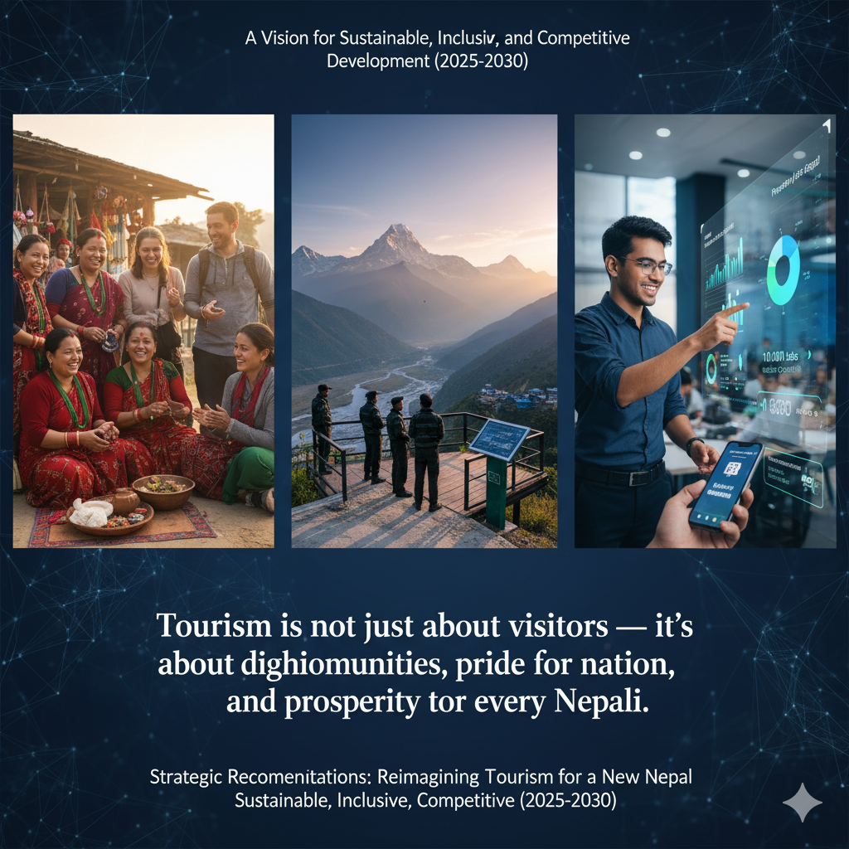
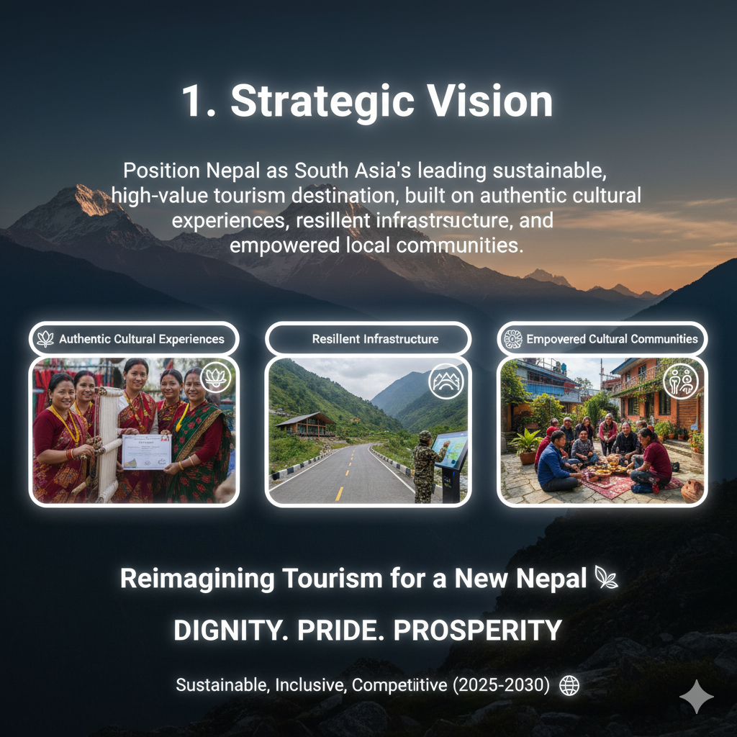
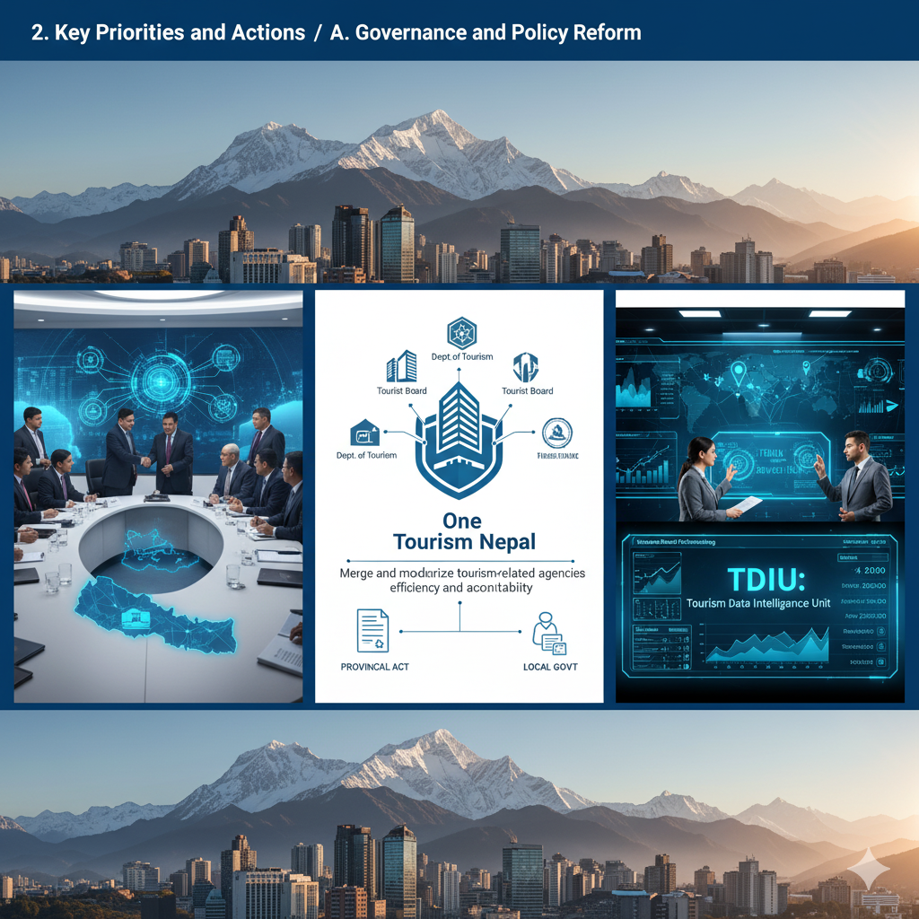
“Tourism is not just about visitors — it’s about dignity for communities, pride for nation, and prosperity for every Nepali.”
A Vision for Sustainable, Inclusive, and Competitive Tourism Development (2025–2030)
1. Strategic Vision
Position Nepal as South Asia’s leading sustainable, high-value tourism destination, built on authentic cultural experiences, resilient infrastructure, and empowered local communities.
2. Key Priorities and Actions
A. Governance and Policy Reform
- Activate the National Tourism Council chaired by the PM for inter-ministerial coordination.
- Merge and modernize tourism-related agencies under a “One Tourism Nepal” framework for efficiency and accountability.
- Activate the Tourism Act to align with federal structures and empower provincial and local governments.
- Initiate a Tourism Data Intelligence Unit (TDIU) for evidence-based policymaking and digital tracking of arrivals, spending, and trends.
B. Infrastructure and Connectivity
- Prioritize completion and quality operation of Gautam Buddha, Pokhara, and Nijgadh airports as international gateways.
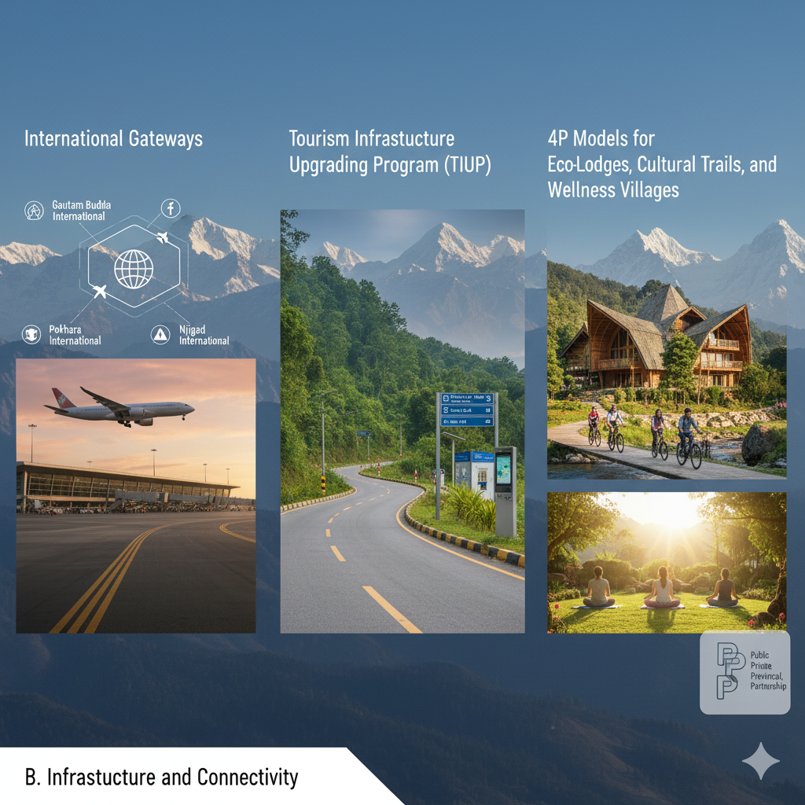
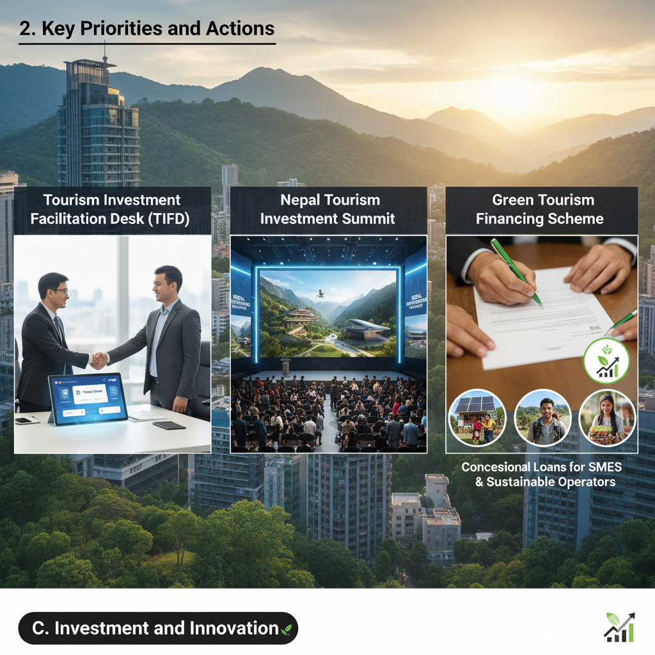
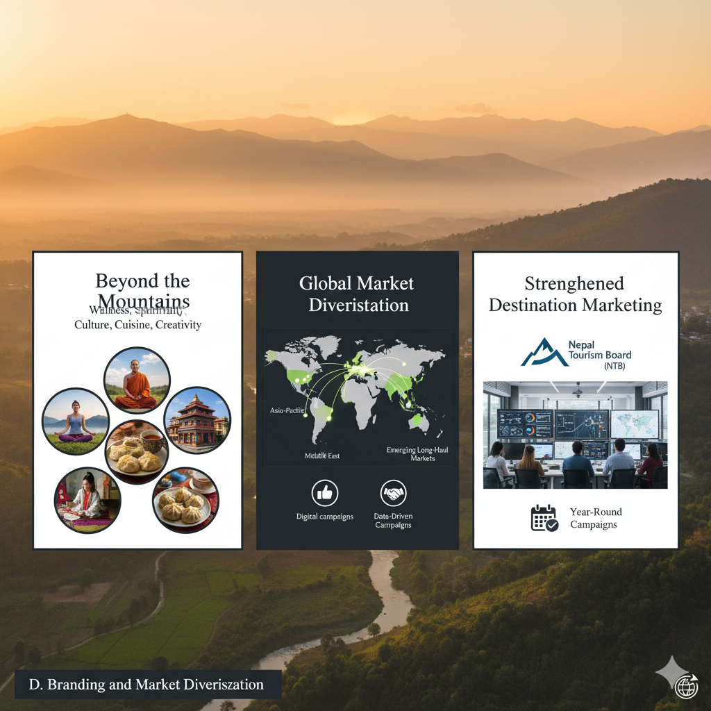
- Initiate the Tourism Infrastructure Upgrading Program (TIUP) for access roads, signage, sanitation, and digital facilities in top 50 destinations.
- Partner with private sector and provincial governments for Eco-Lodges, Cultural Trails, and Wellness Villages through 4P models.
C. Investment and Innovation
- Create a Tourism Investment Facilitation Desk (TIFD) for domestic and foreign investors.
- Introduce “Nepal Tourism Investment Summit” to promote eco-resorts, adventure parks, and MICE venues.
- Develop Green Tourism Financing Scheme with concessional loans for SMEs and sustainable operators.
D. Branding and Market Diversification
- Rebrand Nepal as “Beyond the Mountains” — integrating wellness, spirituality, culture, cuisine, and creativity.
- Focus marketing on Asia-Pacific, Middle East, and emerging long-haul markets with digital campaigns and influencer partnerships.
- Strengthen Nepal Tourism Board as a professional Destination Marketing Organization (DMO) with data-driven, year-round campaigns.
E. Human Capital and Community Empowerment (Ongoing)
- Launch a National Tourism Skills and Certification Program in partnership with TVET and universities.
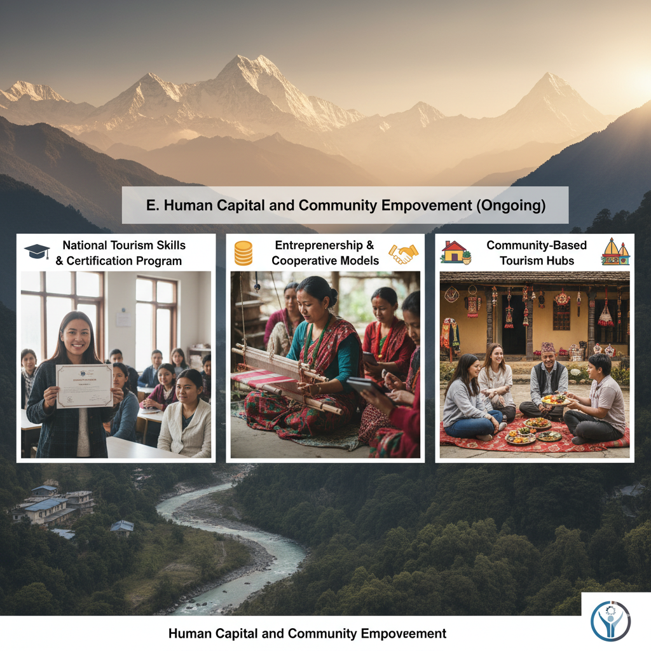

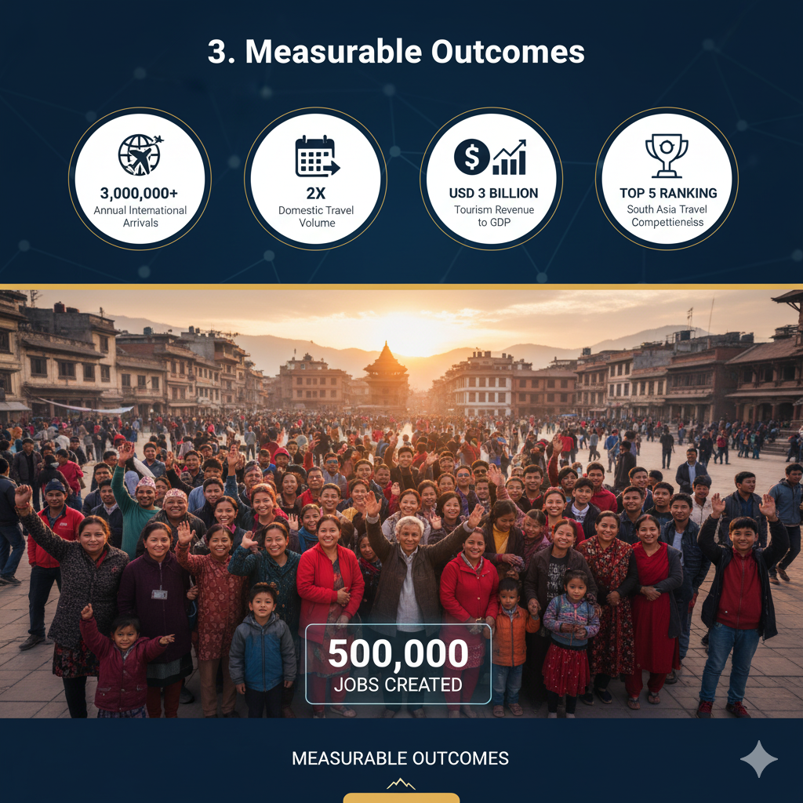
- Empower women, youth, and marginalized groups through Tourism Entrepreneurship Grants and Cooperative Models.
- Support Community-Based Tourism Hubs integrating homestays, crafts, cuisine, and heritage experiences.
F. Digital Transformation
- Build Nepal Tourism Digital Ecosystem integrating e-visa, online booking, digital guides, and real-time visitor analytics.
- Promote Smart Destination Management Systems with local digital kiosks, AR/VR interpretation, and safety monitoring.
3. Measurable Outcomes
- 3 million annual international arrivals and 2x domestic travel volume.
- USD 3 billion tourism revenue contribution to GDP.
- 500,000 direct and indirect jobs created.
- Top 5 ranking in South Asia’s Travel Competitiveness Index.

Proposal for RSP: 10 Strategic Actions for Transforming Nepal’s Tourism Sector (2026–2030)
The key issues, priority actions, measurable targets, and an implementation roadmap for 2026–2030.
1. Tourism SWOT in Nepal:
Nepal’s tourism sector stands at a critical juncture. Despite immense natural and cultural potential, the sector is constrained by structural inefficiencies, low-value tourism patterns, and weak institutional coordination.
Transform Nepal into a high-value, sustainable, and decentralized tourism economy through governance reform, infrastructure modernization, digital transformation, and community empowerment.
2. Key Structural Challenges
- Centralized tourism (Kathmandu–Pokhara–Chitwan dominance)
- Seasonality and market volatility
- Weak infrastructure and accessibility
- Low per-tourist spending (low-value tourism model)
- Fragmented governance and institutional overlap
- Lack of real-time data and digital systems
- Limited community participation and benefit-sharing
3. Strategic Vision (2025–2030)
“Position Nepal as South Asia’s leading sustainable, high-value tourism destination—driven by authentic experiences, resilient infrastructure, and empowered communities.”

4. Priority Actions, KPIs, and Timelines
A. Governance & Institutional Reform
Action 1: Establish “One Tourism Nepal” Authority
- Integrate key tourism institutions under a unified framework  - Activate National Tourism Council chaired by the PM | KPI:  - 50% reduction in policy duplication  - Inter-ministerial coordination time reduced by 40% | Timeline:  12–18 months
Action 2: Tourism Data Intelligence Unit (TDIU)
- Real-time tourism dashboard (arrivals, spending, trends)  - AI-based forecasting system | - 100% policy decisions supported by data analytics  - Monthly tourism performance reporting | Timeline: 6–12 months
B. Infrastructure & Connectivity
Action 3: Operationalize Regional International Airports
- Full-scale operation of Pokhara and Gautam Buddha Airports  - Airline incentives and route expansion | - 30% international arrivals via regional airports  - 20+ new international routes | Timeline: 1–3 years
Action 4: Tourism Infrastructure Upgrade Program (Top 50 Destinations)
- Roads, sanitation, signage, safety, digital connectivity | - 80% tourist satisfaction rating  - Average length of stay increased by 25% | Timeline: 2–5 years
C. Community & Inclusive Development
Action 5: National Community Tourism Program
- Develop 100+ model tourism villages  - Promote homestays, crafts, cultural tourism | - 25% tourism revenue retained locally  - 100,000 rural jobs created | Timeline: 2–5 years
Action 6: Tourism Skills & Certification Program
- Nationwide training (guides, hospitality, digital skills)  - Partnership with universities and TVET | - 200,000 certified tourism professionals  - Service quality index improved significantly | Timeline: Ongoing (start within 6 months)
D. Investment & Innovation
Action 7: Tourism Investment Facilitation Desk (TIFD)
- One-window system for domestic & foreign investors | - USD 1 billion tourism investment mobilized  - Approval time reduced by 50% | Timeline: 6–12 months
Action 8: Green Tourism Financing Scheme
- Concessional loans for eco-friendly tourism enterprises | - 500+ green-certified tourism businesses  - Carbon footprint reduction in key destinations | Timeline: 1–3 years
E. Branding & Market Diversification
Action 9: Rebranding Campaign – “Beyond the Mountains”
- Promote culture, spirituality, wellness, cuisine  - Digital marketing & influencer engagement | - Average spending per tourist doubled  - Diversified source markets (no single market >25%) | Timeline: 1–3 years
F. Digital Transformation
Action 10: Integrated Digital Tourism Ecosystem
- E-visa, booking platform, digital guide, analytics | - 80% tourists use digital platform  - Seamless end-to-end tourist experience | Timeline: 1–2 years

5. National Targets (By 2030) | 7. Concluding Note  Tourism is not merely an economic activity—it is a vehicle for national dignity, cultural preservation, and inclusive prosperity.  Nepal possesses all the fundamental strengths to become a global tourism leader. What is now required is decisive political commitment, institutional reform, and execution excellence.  I remain fully committed to supporting this transformation with my expertise, experience, and continued engagement.  Thank you for your attention.  Yours sincerely,  Dr. Gyanendra Ratna Tuladhar, PhD  Tourism Economical Science, Nepal  https://www.linkedin.com/in/dr-gyanendra-ratna-tuladhar-a53a7224/?originalSubdomain=np  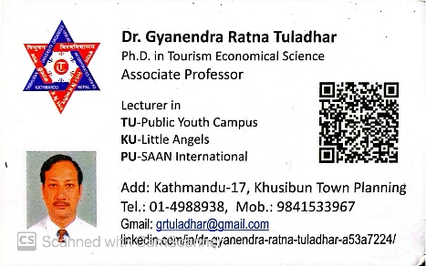
- 3 million international tourists annually
- USD 3 billion tourism revenue
- 500,000 jobs created
- Top 5 tourism destination in South Asia
- Doubling of average tourist spending
6. Implementation Framework
Institutional Mechanism
- National Tourism Council (Policy leadership)
- One Tourism Nepal Authority (Execution)
- Provincial & Local Governments (Implementation)
- Private Sector (Investment & operations)
Financing Model
- Public-Private Partnerships (PPP/4P)
- Foreign Direct Investment (FDI)
- Multilateral support (ADB, World Bank, UNWTO)
- Green financing instruments
Monitoring & Evaluation
- Quarterly performance dashboard (TDIU)
- Annual Tourism Competitiveness Report
- Independent policy audit mechanism

